Module 3
1. Guest Types – Business, Corporate, Family, Solo
Guests are grouped by purpose of travel:
- Business
- Corporate
- Family
- Solo
Each segment behaves differently in terms of duration, spending, and booking patterns, which directly affects revenue and occupancy strategies.

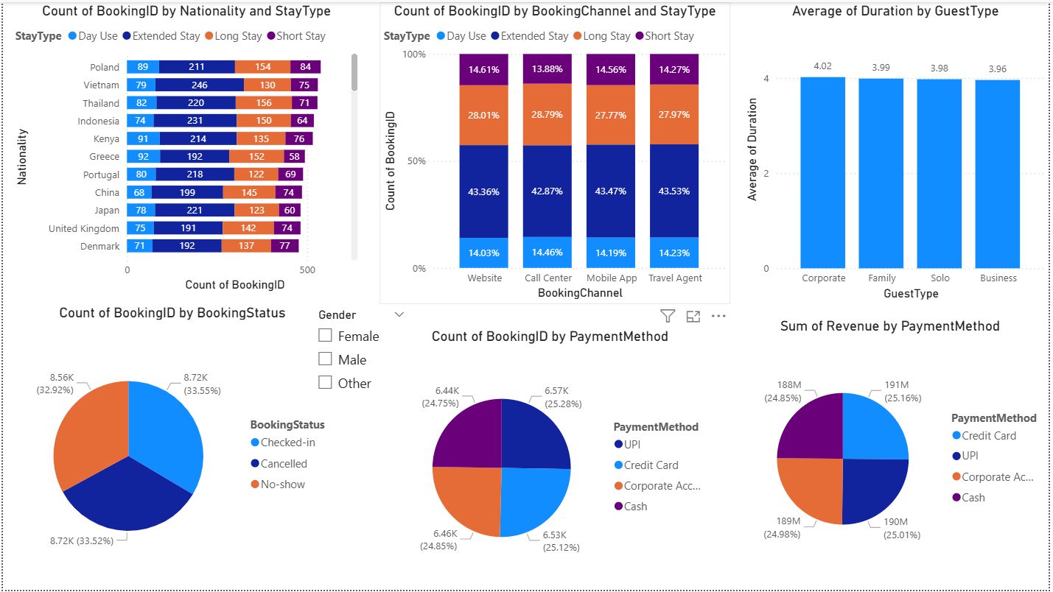

2. Visuals – Nationality, Booking Source, Duration
Nationality
Shows where guests come from and which countries contribute the most volume.

Booking Channels
Website, OTA, Travel agents, Mobile app etc.—helps identify which channel brings which type of guest.
Duration
Bar chart shows average length of stay:
- Family stays much longer
- Solo and Corporate have shorter visits
Useful for long-stay packages vs business-day pricing.
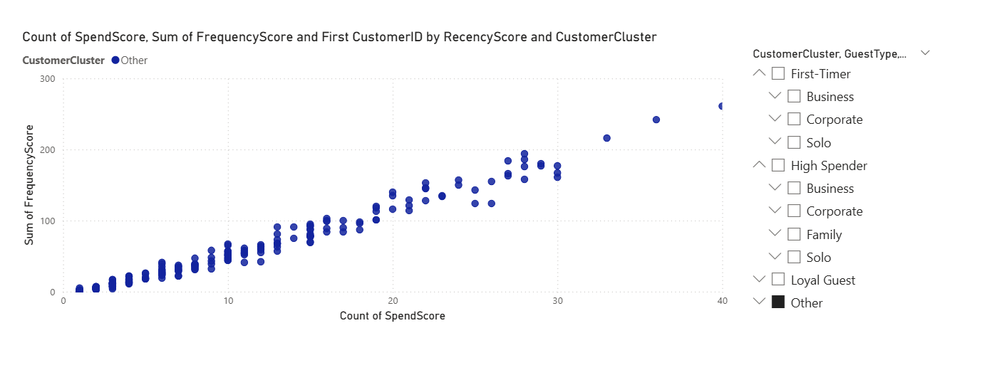

3. Customer Clusters – First-timers, Loyal, High Spenders
RFM-based segmentation highlights:
- First-Timer guests
- Loyal repeat customers
- High-Spend customers
Map visualization and scatter plots locate segments geographically and financially.
This helps discover profitable markets and loyalty drivers.
